School’s Responsibility  We, school staff, will share the responsibility to improve student’s academic achievement and achieve the state’s high standards. Specifically, we will:  - Provide high-quality curriculum and instruction in a supportive and effective learning environment that enables the participating children to meet the state’s student academic achievement standards.  - Hold parent-teacher conferences during which this compact will be discussed as it relates to the individual child’s achievement. Specifically, those conferences will be held in October.  - Provide parents reasonable access to staff. Staff are available for conferencing with parents via email, phone, or in person. Avenues of contact are available through our campus website.  - Provide parents opportunities to be active participants with their child’s learning. |  | Parent’s Responsibility  We, as parents or guardians, will share the responsibility to improve our child’s academic achievement and achieve the state’s high standards. Specifically, we will:  - Ensuring their child comes to school on time every day.  - Ensures homework is completed.  - Participates, as appropriate, in decisions relating to their children’s education.  - Promotes reading for enjoyment.  - Communicating with the school about changes that may affect school.  - Serving to the extent possible, on advisory groups, such as being the Title 1, Part A parent representative on the school’s School Improvement Team, the Title 1 Policy Advisory Committee, the District with Policy Advisory Council, the State’s Committee of Practitioners, the School Support Team or other school advisory or policy groups |  | Student Responsibilities  We, as students, will share the responsibility to improve our academic achievement and achieve the state’s high standards.  Specifically, we will:  - Do my homework every day and ask for help when needed.  - Read at least 30 minutes every day outside of school time.  - Master my High Frequency Words.  - Give my parents or the adult who is responsible for my welfare all notices and information received by me from my school every day.  - Practice and master by me essential standards that include:  - Reading for comprehension  - Practicing my writing using proper punctuation, capitalization, and sentence structure.  - Using our campus wide problem-solving math model to solve word problems  - Develop my fluency with math facts

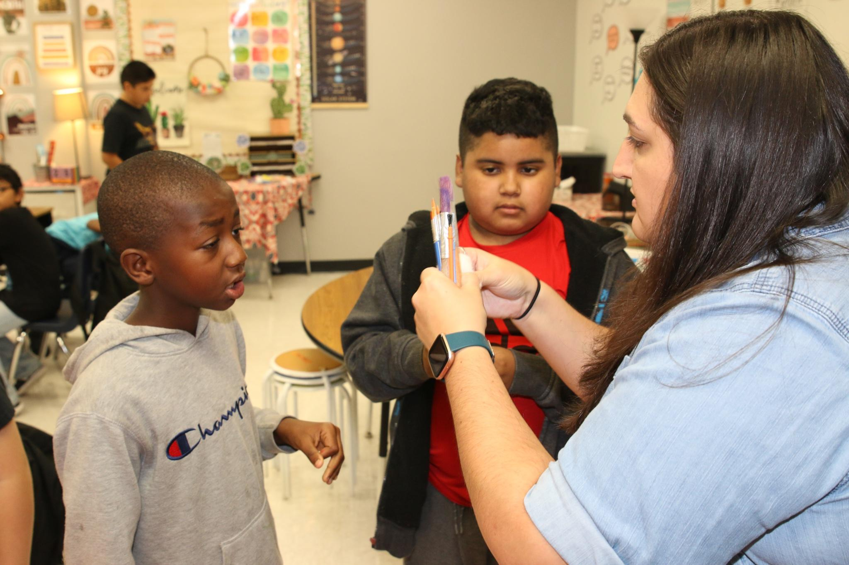  Goal 1: Excellence in Student Outcomes  Goal 2: Exceptional Workplace Climate  Goal 3: Quality Customer Service  Goal 4: Efficient Financial Stewardship  Goal 5: School Safety  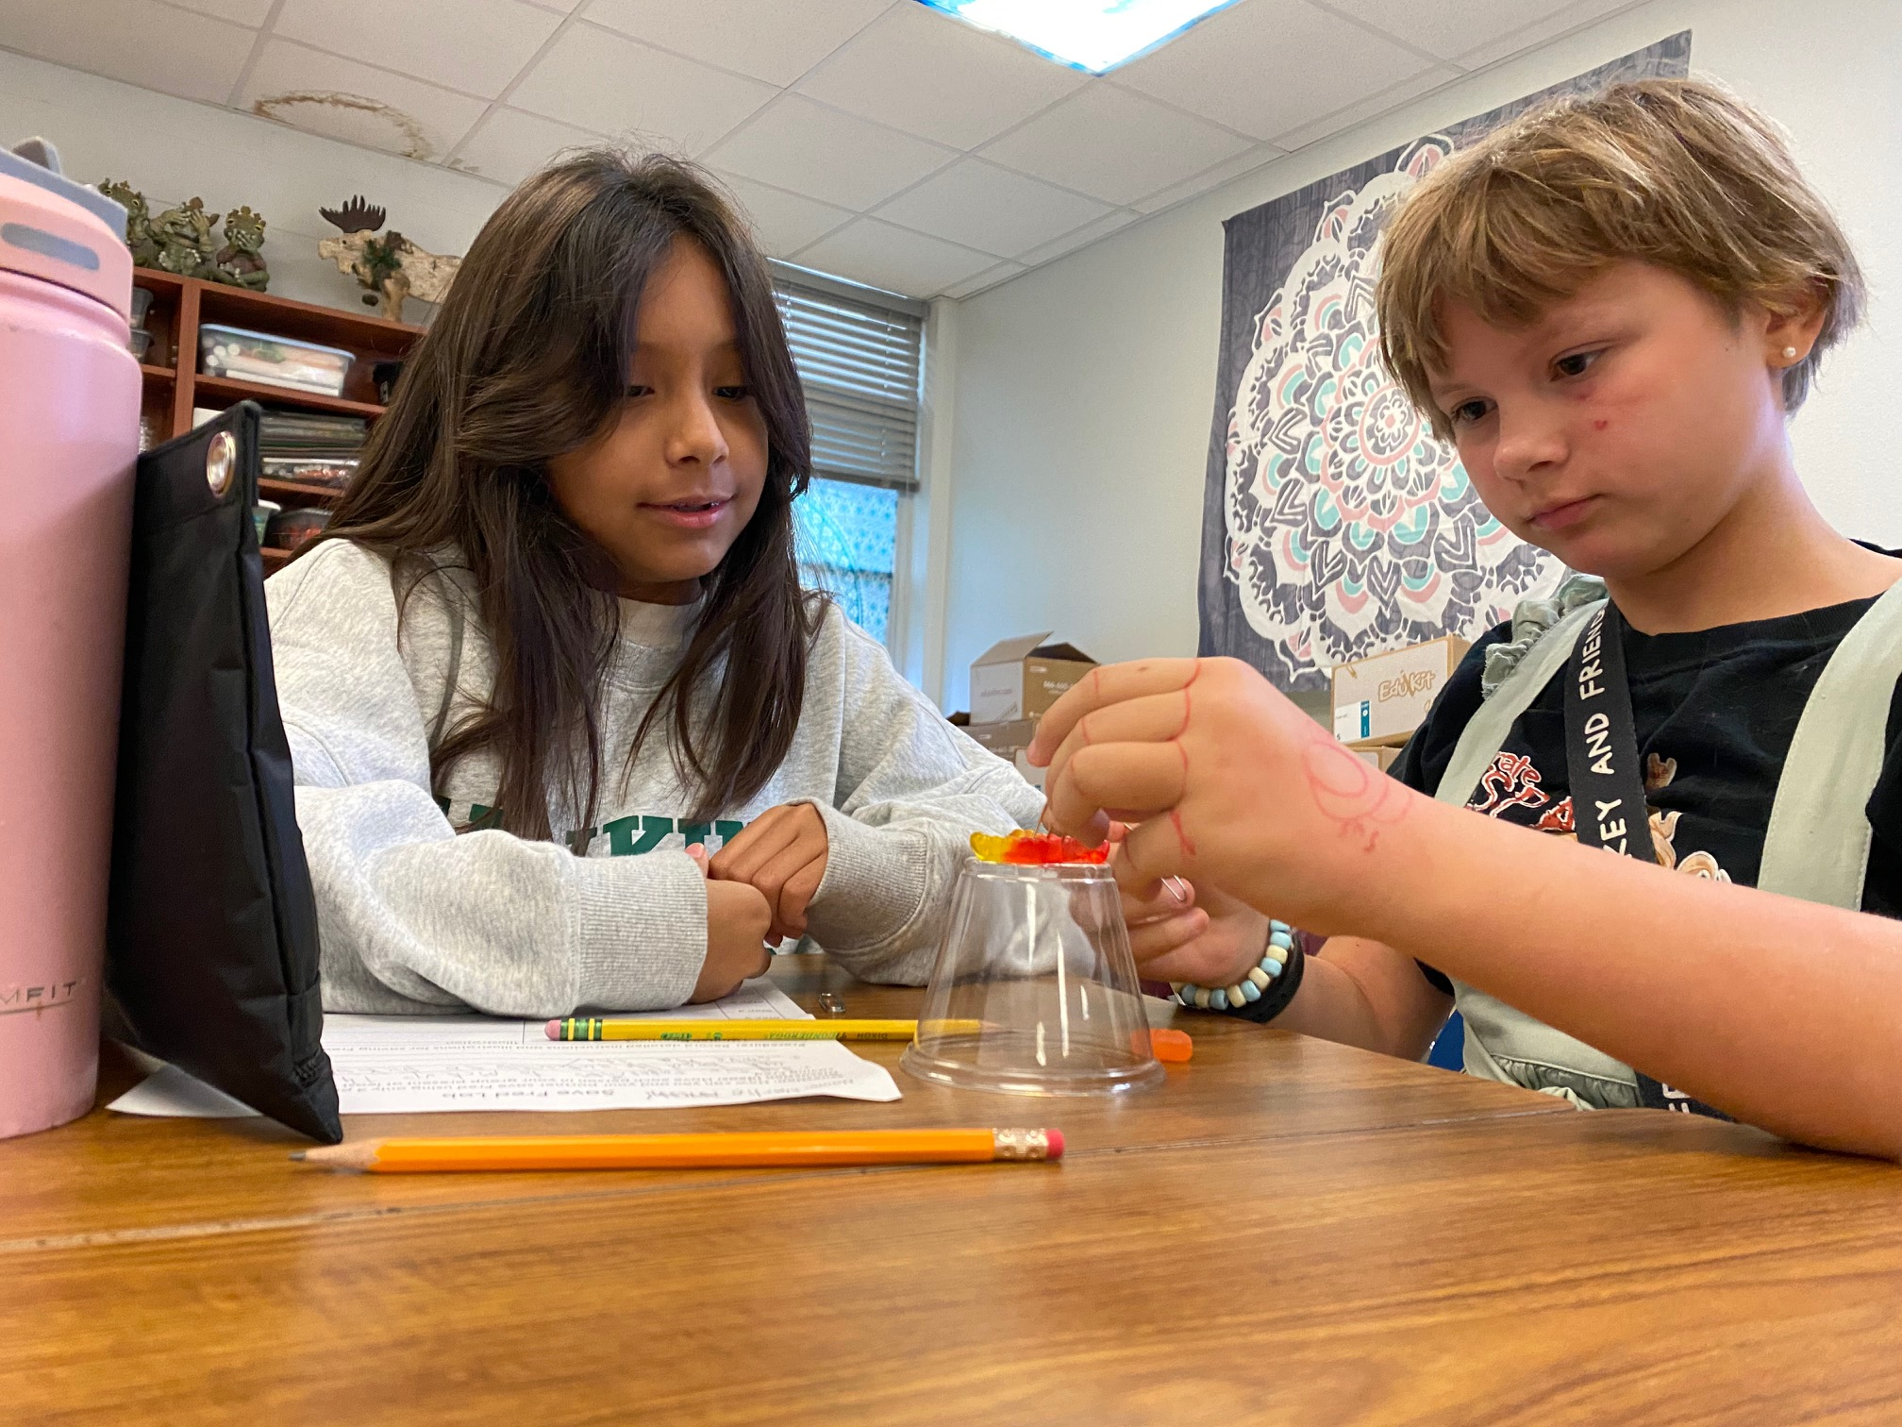 |  | 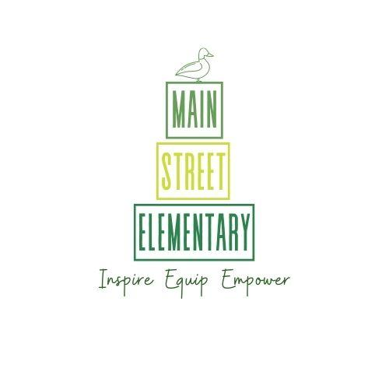  Main Street Elementary and the parents of the students participating in activities, services, and programs funded by Title 1, Part A of the Elementary and Secondary Education Act (ESEA), agree that this compact outlines how the parents, the entire school staff, and the students will share responsibility for improved student academic achievement and the means by which the school and parents will build and develop a partnership that will help children achieve the state’s high standards.  This school-parent compact is in effect during the 2023-24 school year. |  | Taylor ISD inspires, equips, and empowers every student to reach their unique potential.  Intentionally powering the whole child.  

